**Concept Selection**

Once concept generation was complete, tools such as Binary Pairwise Comparison, House of Quality, Pugh Charts, and the Analytical Hierarchy Process (AHP) were employed to evaluate our concepts. These methods use a structured analytical approach to quantify and assess concepts in relation to customer needs. Ultimately, they convert qualitative ideas into a numerical framework, facilitating informed design decisions.

**Binary Pairwise Comparison**

The Binary Pairwise Comparison chart helps assess the importance of each customer's need and rank them accordingly. In Figure 1, the chart is shown as part of the analysis to establish weight factors for the House of Quality. This process enabled the team to identify which customer needs should take priority in the final design.

To conduct the analysis, the team compared each row against the column by asking whether the need in the row was more important or less important. If the need in the row was deemed more important, a score of 1 was assigned; if less important, a score of 0. The opposite values were assigned in the transposed positions. This comparison continued until the entire matrix was filled.

After populating the matrix, the team summed the values in the columns and rows to calculate an “Importance Weight Factor,” which was then incorporated into the House of Quality chart. From this analysis, the most critical customer needs emerged: Able to accurately relay system information, rocket able to be assembled in two hours' time, and rocket lands with less than 50 G’s. These findings align with the project's goals as outlined by the customer.

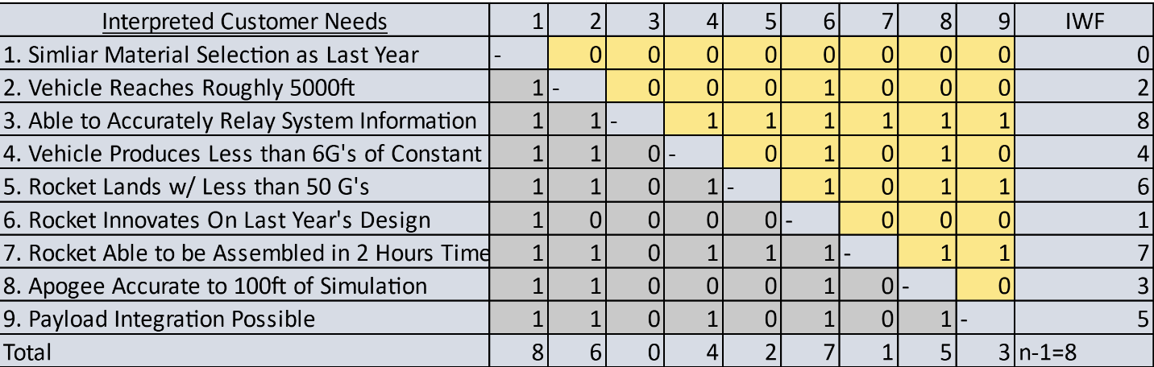

*Figure 1 Binary Pairwise Comparison Chart*

**House of Quality**

The House of Quality aims to convert customer needs into measurable design variables, known as engineering characteristics. These characteristics are critical for the final design and deserve careful consideration. Figure 2 displays the generated House of Quality chart, which utilizes a 1-3-9 scale to assign values based on how well each characteristic meets the corresponding customer need.

To identify the most significant engineering characteristics for the Pugh chart, the top six were selected based on their relative weight value, which needed to exceed the median of 11.11%. The key engineering characteristics, ranked from most to least important, include: Weight, time to set up, speed, redundancy, transmitting information, and thrust generation. These selected characteristics closely align with customer values and will inform the next stages of the design selection process, including the Pugh charts and the Analytical Hierarchy Process for further evaluation. Conversely, characteristics that were not included are reusability, reduces drag, and resist environmental factors.

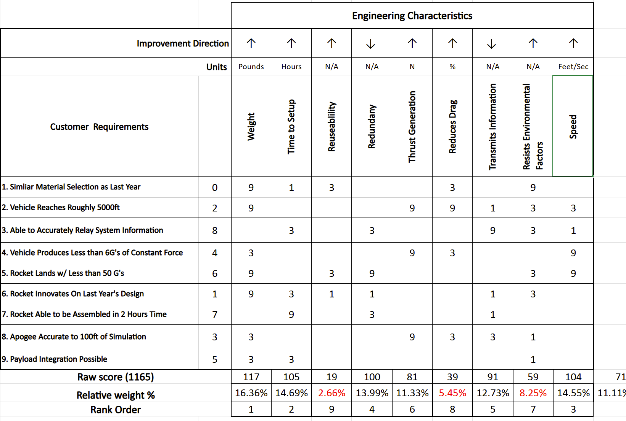

*Figure 2 House of Quality Chart*

### **Pugh Chart**

The Pugh chart evaluates the key engineering characteristics identified from the House of Quality against various design concepts. Figure 3 illustrates the first Pugh chart, using last year's rocket design, Zenith 2, as the reference datum. Zenith 2 performed adequately in the previous competition and serves as a reliable benchmark due to its stability, apogee, and mass, making it suitable for comparison with this year’s designs.

In the Pugh chart, the rows represent the engineering characteristics, the columns list the design concepts, and the leftmost column features the datum, which is last year's design. Each concept is assessed with a notation of “S,” “+,” or “-.” An “S” indicates similarity between the concept and the datum for that characteristic, a “+” denotes that the concept is superior, and a “-” signifies that it is inferior. The scores are summed up at the bottom of the chart.

Figure 4 presents the second Pugh chart, which further refines the design ideas. For this chart, the concept of Light Rocket was selected as the datum, as it exhibited a balanced number of pluses and minuses, making it an effective baseline for comparison. From this chart, the concepts big rocket, cheap rocket, light rocket, heavy rocket, and small rocket were discarded due to the highest count of “-” ratings and not as many “+”. Conversely, the concepts of expensive rocket, balanced rocket and conservative rocket were retained for further analysis, as they demonstrated significant advantages over the datum. These three concepts will be utilized in the Analytical Hierarchy Process.

|  |  |
| --- | --- |
| C1 – Big Rocket | C5 – Heavy Rocket |
| C2 – Expensive Rocket | C6 – Small Rocket |
| C3 – Cheap Rocket | C7 – Balanced Rocket |
| C4 – Light Rocket | C8 – Conservative Rocket |

*Chart 1 Concepts*

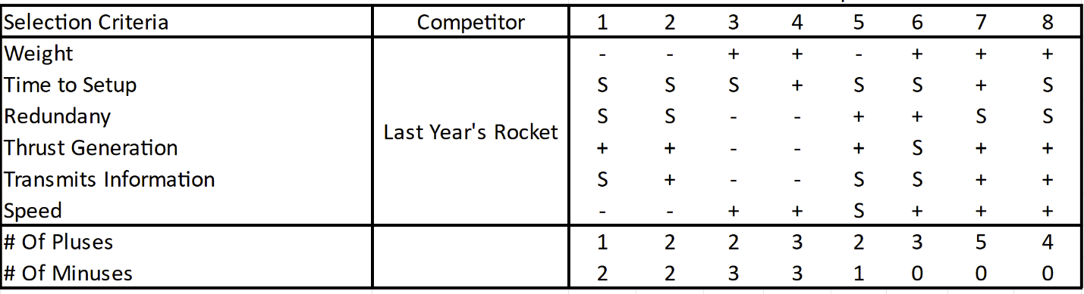

*Figure 3 Pugh Chart 1*

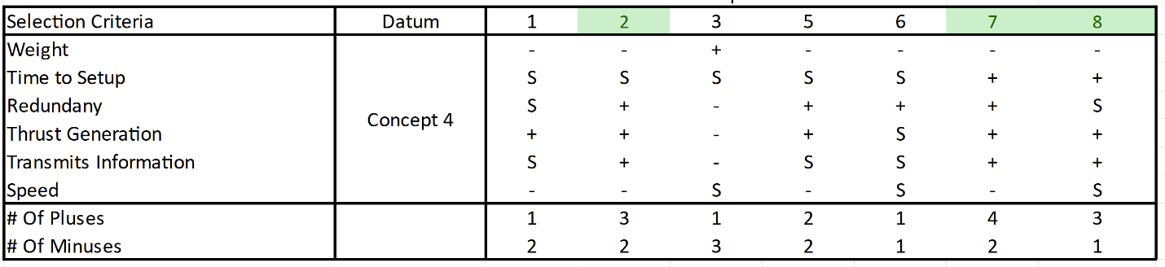

*Figure 4 Pugh Chart 2*

**Analytical Hierarchy Process**

This section outlines the stages of the Analytical Hierarchy Process. Figure 5 displays the criteria comparison matrix, which facilitates the evaluation of each selection criterion against one another to identify the most important factors in the decision-making process. This matrix quantifies small qualitative judgments using a 1-3-5-7-9 scale. If a criterion in the column is deemed more important than the one in the row, a corresponding whole number is assigned to indicate the degree of importance. The inverse value is recorded in the transposed element of the matrix. The total for each criterion is then summed and presented in the bottom row.

Following this, a new matrix called the normalized criteria comparison matrix is created, as shown in Figure 6. This matrix normalizes the columns of the initial matrix by dividing each element by the sum of its respective column. The rows are then summed and divided by the number of elements in each row to calculate the criteria weights, denoted as W. Among these, the criterion with the highest weight is transmits information, while the criterion with the lowest weight is speed.

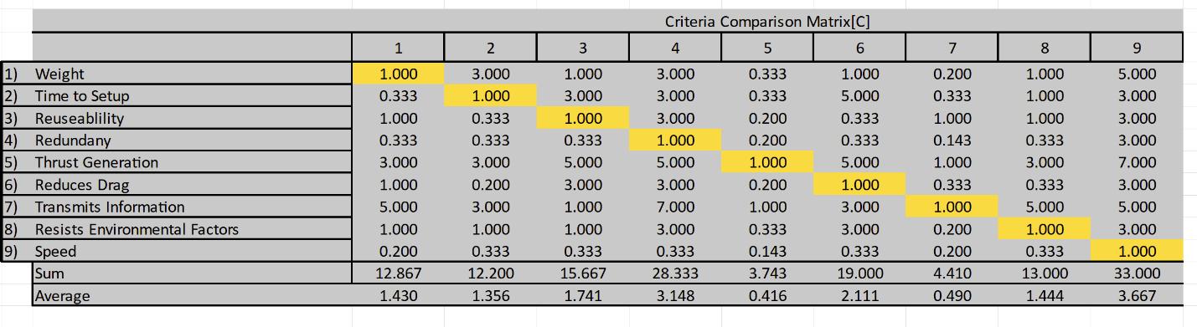

*Figure 5 Criteria Comparison Matrix*

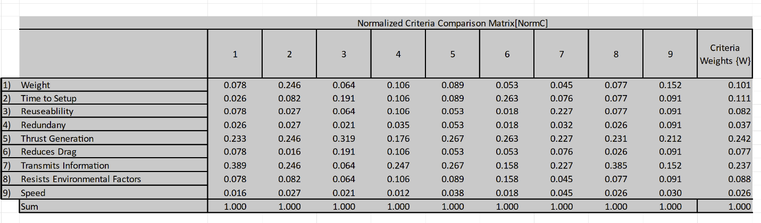

Figure 6 *Normalized Criteria Comparison Matrix*

To eliminate any biases in the decision-making process and verify the consistency of the results, additional analysis was performed. Figure 7 displays the findings of this analysis. The first column represents the weighted sum vector, which is calculated by multiplying the criteria comparison matrix by the criteria weights. The criteria weights derived from Figure 6 are shown in the second column. The third column presents the consistency vector, obtained by dividing the weighted sum vector by the criteria weights. This consistency vector is then summed and divided by the number of elements to calculate the average consistency. To determine the random index value (RI), a reference table for six elements was used. The equation is as follows:

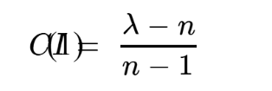

The consistency index (CI) was calculated using the formula where CI is the consistency index and “n” represents the number of elements. The team determined the CI value to be 0.158. Next, the consistency ratio (CR) was calculated using the following equation:

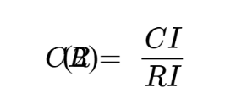

A consistency ratio (CR) value of less than 0.1 indicates that the selection process is unbiased. The consistency check revealed that the team’s selection process was indeed unbiased, as the CR value was found to be 0.093, which is below the threshold of 0.1.

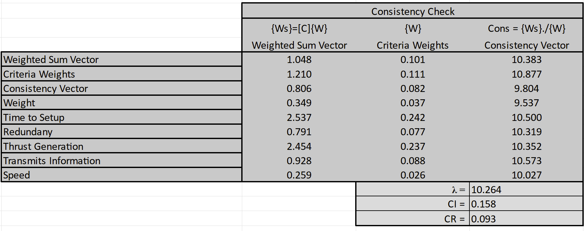

*Figure 7 Consistency Check*

The criteria comparison matrix, normalized criteria comparison matrix, and consistency check process were repeated to evaluate the top three concepts against each selection criterion. These charts can be found in Appendix C. The results of these comparisons are presented in Figure 8, which lists the design alternative priorities (Pi) for each concept and selection criterion.

In Figure 9, the alternative values were calculated by transposing the final rating matrix and then multiplying it by the criteria weights from Figure 7. The concept with the highest alternative value was identified as the superior design, as it best meets the customer’s needs. Ultimately, the final decision is the balanced design concept.

*Figure 8 Final Rating Matrix*

*Figure 9 Alternate Value Table*

### **Final Selection**

Figure 9 above shows that our best concept for our customer’s needs will be our balanced rocket concept. This concept consists of many basic high-powered rocket designs that last year’s team used for their vehicle; however it innovates on those designs and helps optimize the rocket for what the competition requires of it.

There are three main differences from last year’s design that ours incorporates. Firstly, the nose cone. Our nose cone will be printed with Nylon 12 through the FSU Innovation Hub like last year, however our new nose cone has pockets specifically designed to house a certain amount of epoxy which will make our CAD-to-fabrication weights much more similar. Our nosecone will also not be printed with complete infill; rather, ours will have hollow sections supported by brackets to reduce the weight of the overall rocket significantly. Its bottom section will also be configured to allow the payload to connect to it, giving the payload a sturdy connection point. Figure 10 below shows our current CAD drawing of the nosecone and its separate sections.

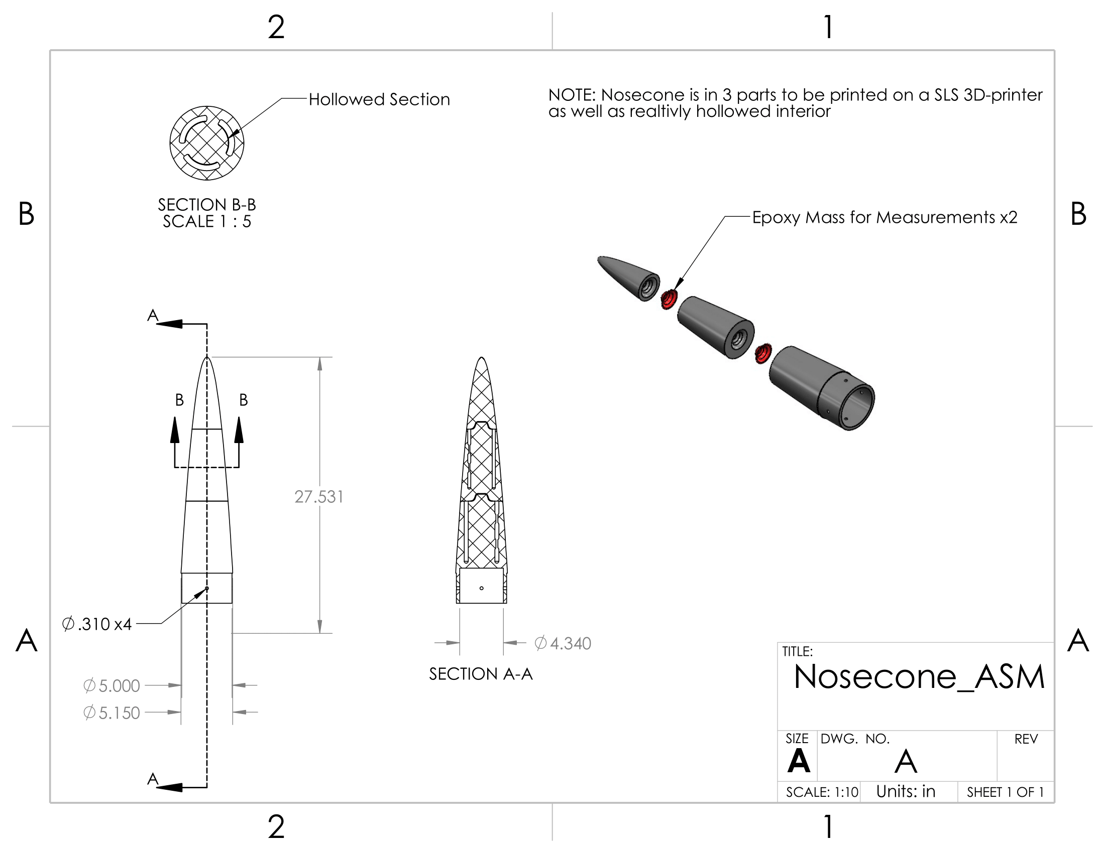

*Figure 10 Nose Cone Design*

The second big difference from last year’s design is our avionics bay. Last year, the avionics bay consisted of two threaded bolts running through the entire section, with nothing but a 3D printed middle section to house the electronics. This 3D printed middle section did not fare well in flight, having nothing but a few connections left to the two threaded bolts by the end of its last flight. To counter this, our design this year will incorporate wooden “compartments” within the avionics bay that are separately connected to four threaded bolts that run through the entire section. This design allows the avionics bay to be much more resilient to the rocket’s separation and landing forces, as well as making the process of opening and closing the avionics bay much simpler for the user, which should decrease our setup time drastically. Figure 11 below shows our current CAD drawing of the avionics bay.

*Figure 11 Avionics Bay Design*

Lastly, the third big difference from last year’s design is the overall diameter of the rocket. Last year’s design had a 6-inch diameter rocket, which we do not believe is necessary for the challenge NASA has tasked us to do. Thus, our rocket’s design this year calls for a 5-inch diameter rocket which doesn’t stray too far from last year’s design but removes a tremendous amount of unnecessary weight. Figure 12 below shows our current full body rocket CAD, encompassing all aspects talked about and more. This design will be tested through our subscale vehicle, which will fly mid-December.

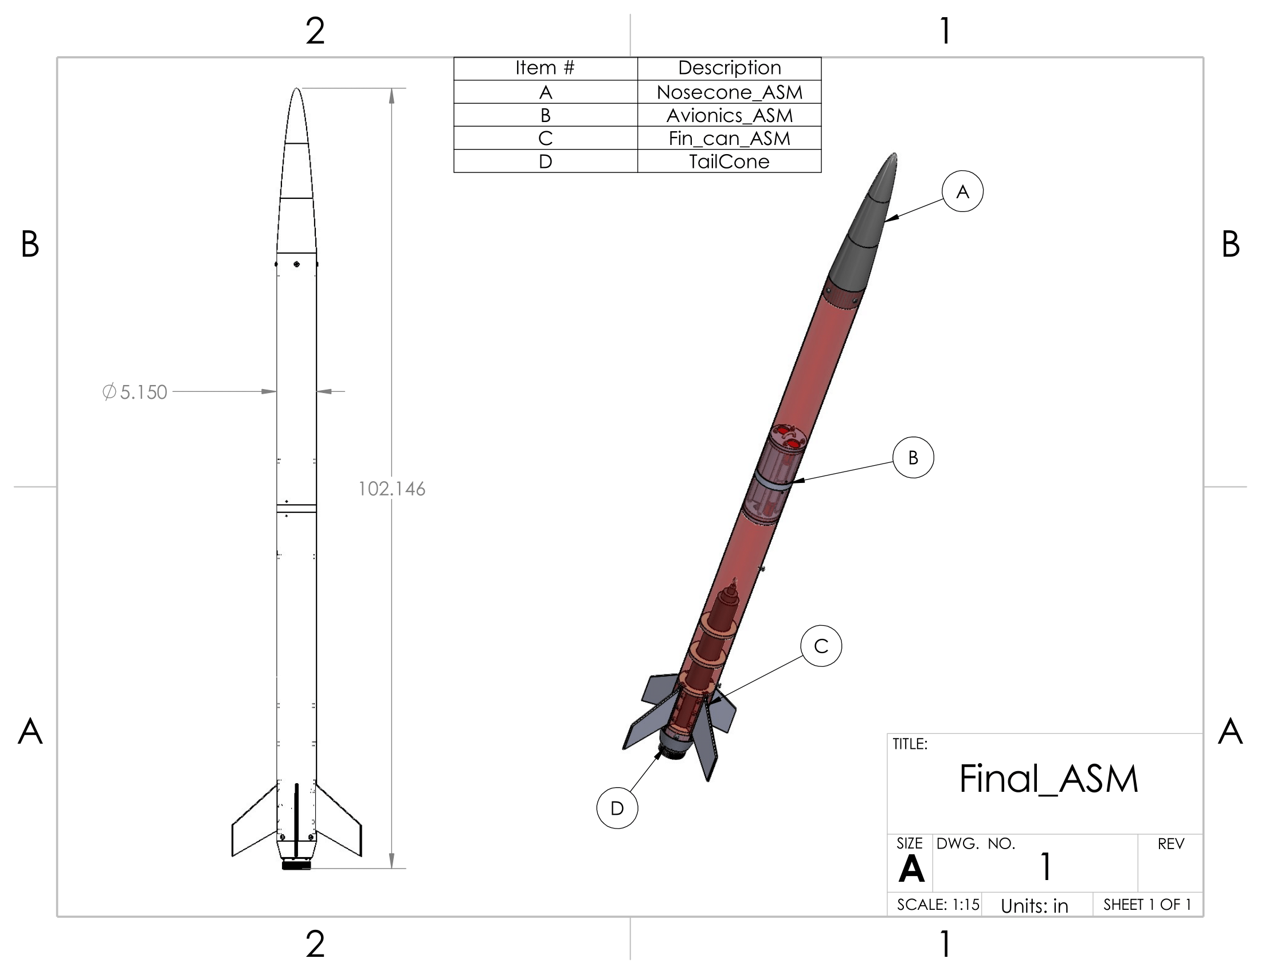

*Figure 12 Full Rocket Design*

**Appendix**

*Binary Pairwise Comparison Chart*



*House of Quality Chart*



*Pugh Chart 1*

*Pugh Chart 2*

*Criteria Comparison Matrix*

*Normalized Criteria Comparison Matrix*

*Consistency Check*

*PI Charts*

*Normalized PI Charts*

*Final Rating Matrix*

*Alternate Value Table*